Test Process Using Zephyr-JIRA

Table of Contents
I. Creating Test Cases 2
II. Adding Test Cases to Test Cycles 5
III. Executing Test Cases 8
IV. Re-using the test cycle for different tests 11
V. Others 12

Revision History

Date | Author | Description | Version
April 18, 2016 | Des Tayag | Initial Draft | 0.1
April 19, 2016 | Des Tayag | Added glossary, improve document layout | 0.2

Definition of Terms

Term | Definition
Test Cycle | A grouping of executed or unexecuted tests  (e.g. "Functionality", "Regression" etc.)  More than one test cycle can exist for a Version.
Test Plan | A document that will cover what tests to be executed for a group of test cases for a certain release or planned schedule of test
Test Case | This is a detailed step-by-step description of what should be done to test something.  This can be as high level or detailed as possible, with links to requirements, lots of properties, execution history etc. In JIRA, its a standard issue-type.
Test Summary | High level summary and counts of all the tests that have been created in a particular project, grouped in various ways.
Test Steps | These are the group of steps that will consist the test cases. Each test steps is executable.
Version | Version are set of tasks to be released on a specific time on the client live site. The Version teams set up in JIRA. Tests need to belong to Fix Version/s.

Creating Test Cases

- Go to the project that needs test planning and execution.
- Check on the upcoming version release and the JIRA tasks under it. Its good to know what version is scheduled for release and to know what tasks needs to have test cases.

- Once the version and JIRA tasks is known, then begin planning on what test needs to be conducted.

Document needed is a Test Plan.

- Then go to Tests/Test Summary
- Under the Test Summary, click on the upcoming version
- The test cases list page shows. Click on Create a new Issue link to create a test case
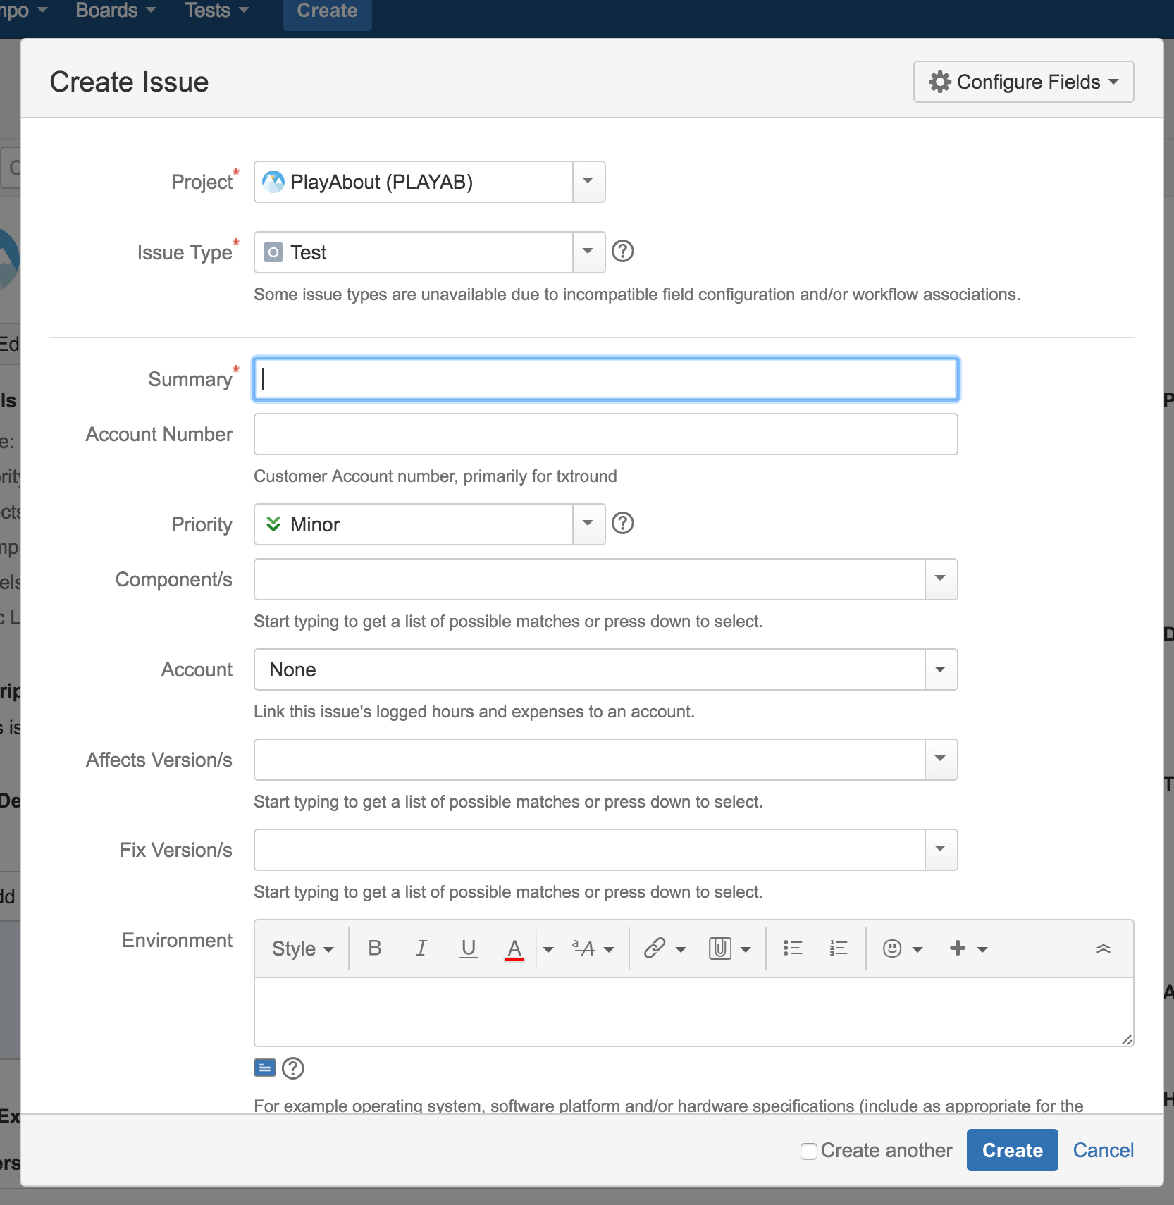

- On the Create Issue form, select the following:
  - Project : <Project Name> Example: INFRA
  - Issue Type : <Issue Type> Used: Test
  - Summary: <Test Case title>
Format: <JIRA ID>-<Test Case ID>:<Test Case Title>
Example: INFRA-510-001:This is a test case 1
  - Priority: <choose how important the test case is>
  - Component: <can select on pre-existing or create a new component> (Component can be used for grouping test cases just like Version)
  - Affect Version/s: <Version for Planned testing>
  - Description: <Description of what the test is all about.>
  - Original Estimate: <how much time will the test case be executed>
  - Labels: (optional field) <can be use to link test case>
  - Sprint: <Sprint #> optional field since Test Cases can be started even if the Sprint has not yet started
  - Click Create button ( if needs to create a new test case, just click on Create Another checkbox)
  - The test case is created
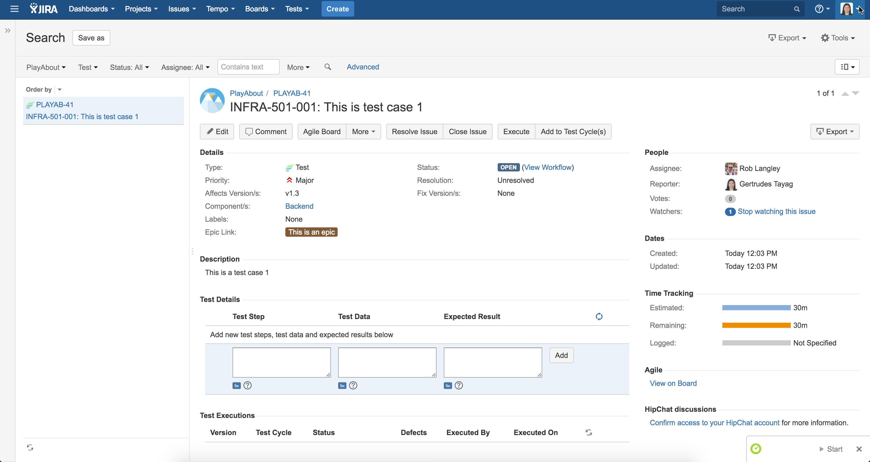

  - The test case is now ready for steps to be added
  - Go to Test Details section
  - Start adding the steps for the test cases(Be detailed as much as possible and add test data needed.)
Test Step | Test Data | Expected Result
Open the Site | www.google.com | The site opened.
Go to Search area |  | Able to go to the Search area
Search for an item by typing it on the search field | “Agile” | Able to type the Test data on Search field
The site will provide search suggestion |  | Able to produce search suggestion
Click on a suggestion | “Agile” | The site will show search results based on the chosen suggestion

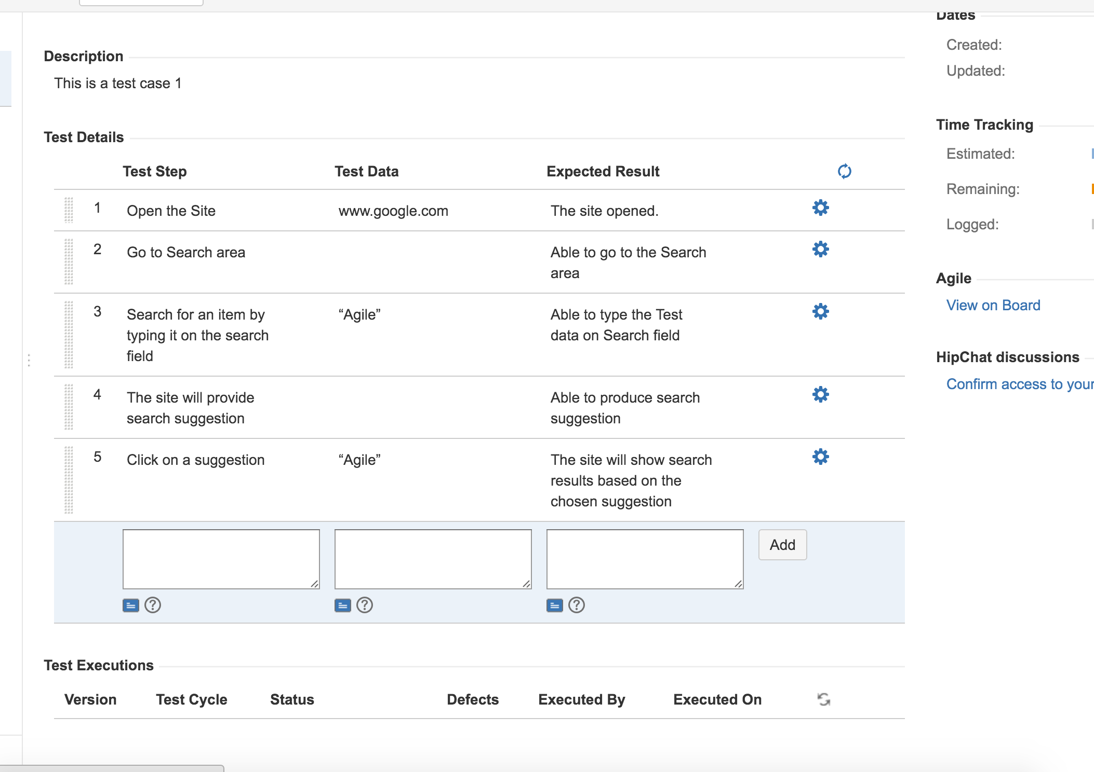

  - Repeat as soon as all of the test cases are done.

Adding Test Cases to Test Cycles
- Go to project
- Go to Tests
- Go to Test Cycles tab
- Create a Test Cycle
- Choose the following data on each field on Create New Test Cycle form
  - Version: <version when to run the test cycle>
  - Name: <Name of the Test Cycle>
Format: Version_<Version Number>-Build_<Build>-Environment_<Environment>: <Name>
Example: Version_1.3-Build_001-Environment_Staging: Regression Testing
  - Description: <description for the test cycle>
  - Build: <build version to run the test cycle>
  - Environment: <location where to run the test cycle>
  - From: <Execution start date>
  - To: <Execution end date>
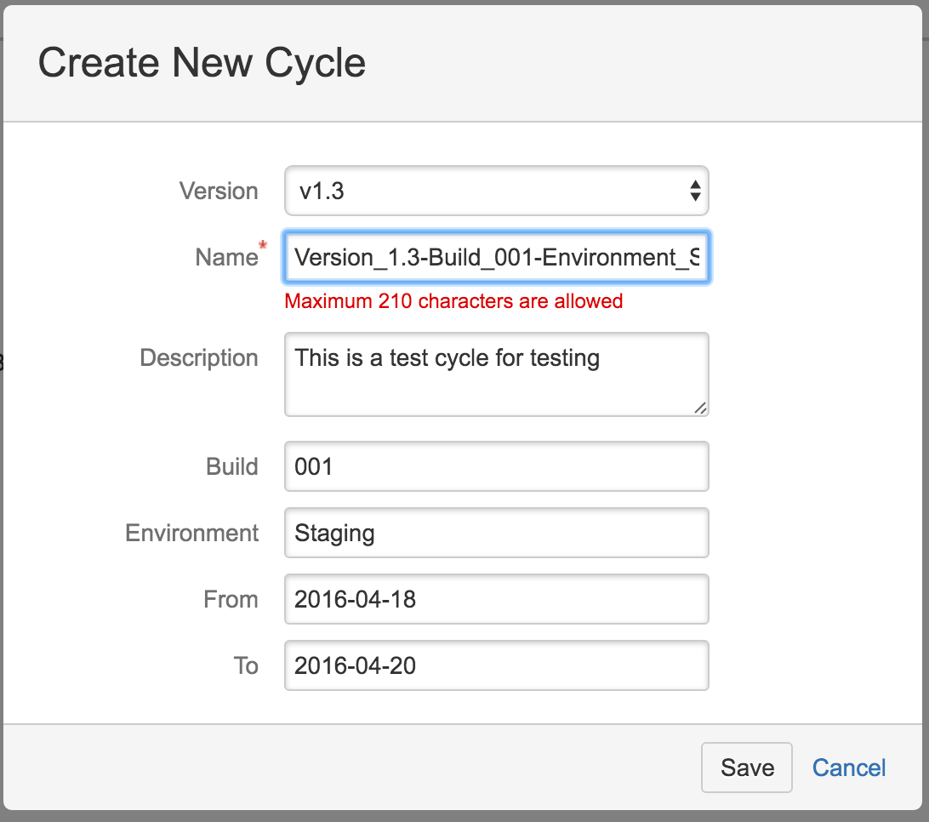

- Click Save
- The test cycle is now added
- Need to add test cases to the test cycle
- On the Test Cycle list, click the wrench icon(Settings)
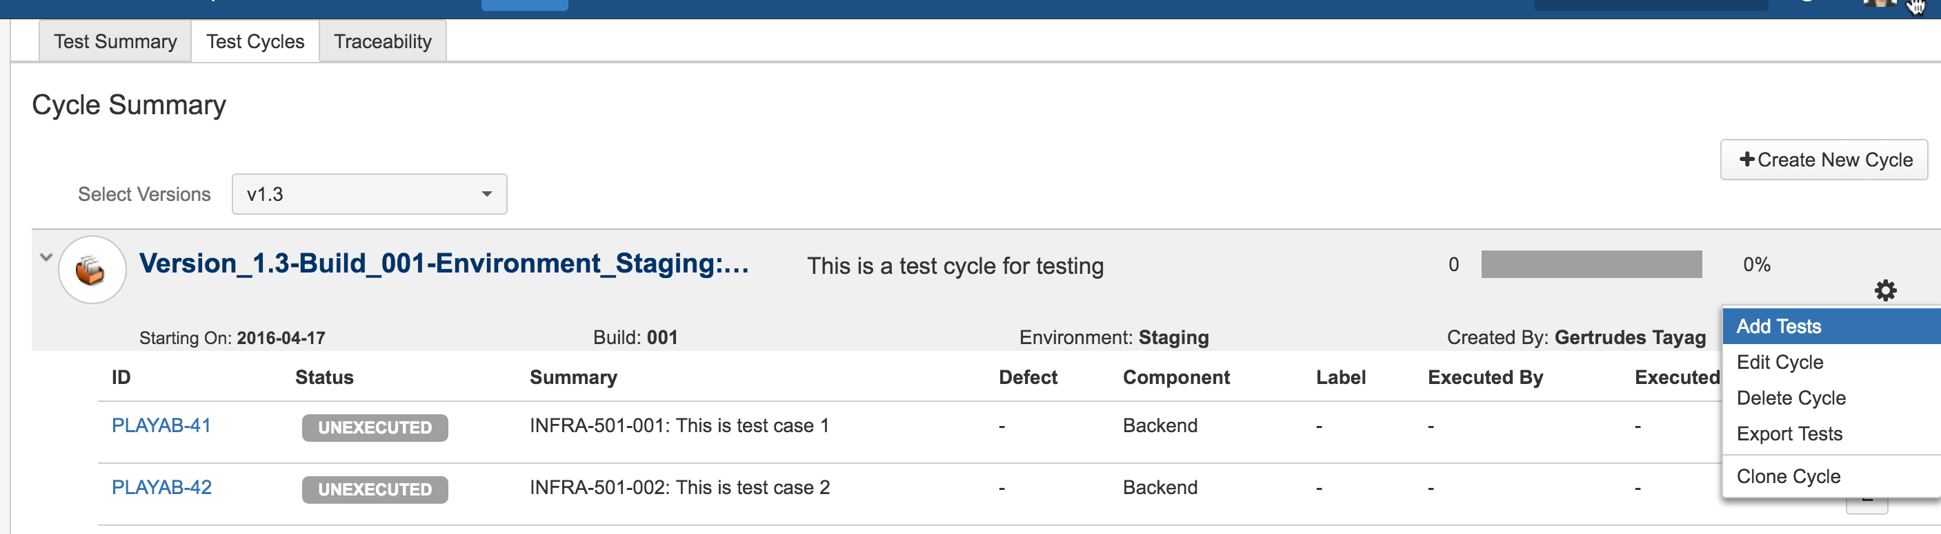
- Click Add Tests
- Search for the test cases(a little tedious as needs to add test cases one by one)
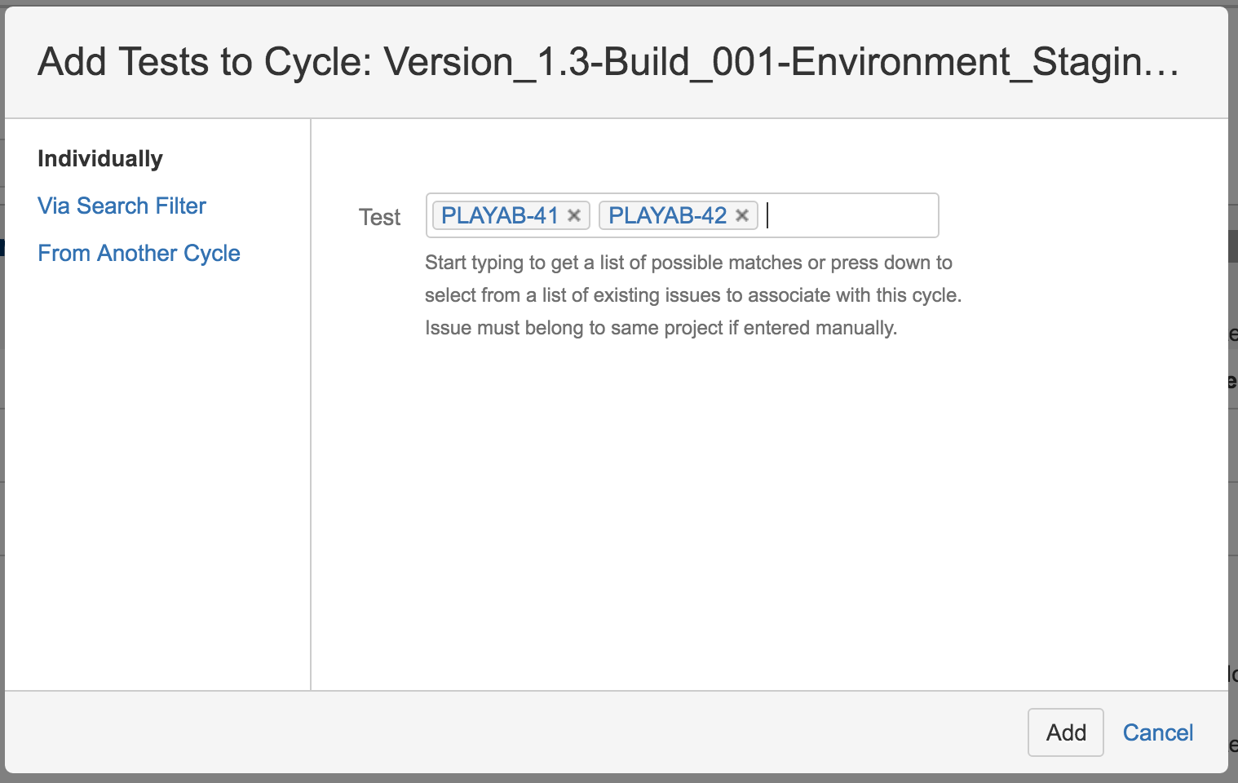
- Click Add
- The test cases are now added to the test cycle
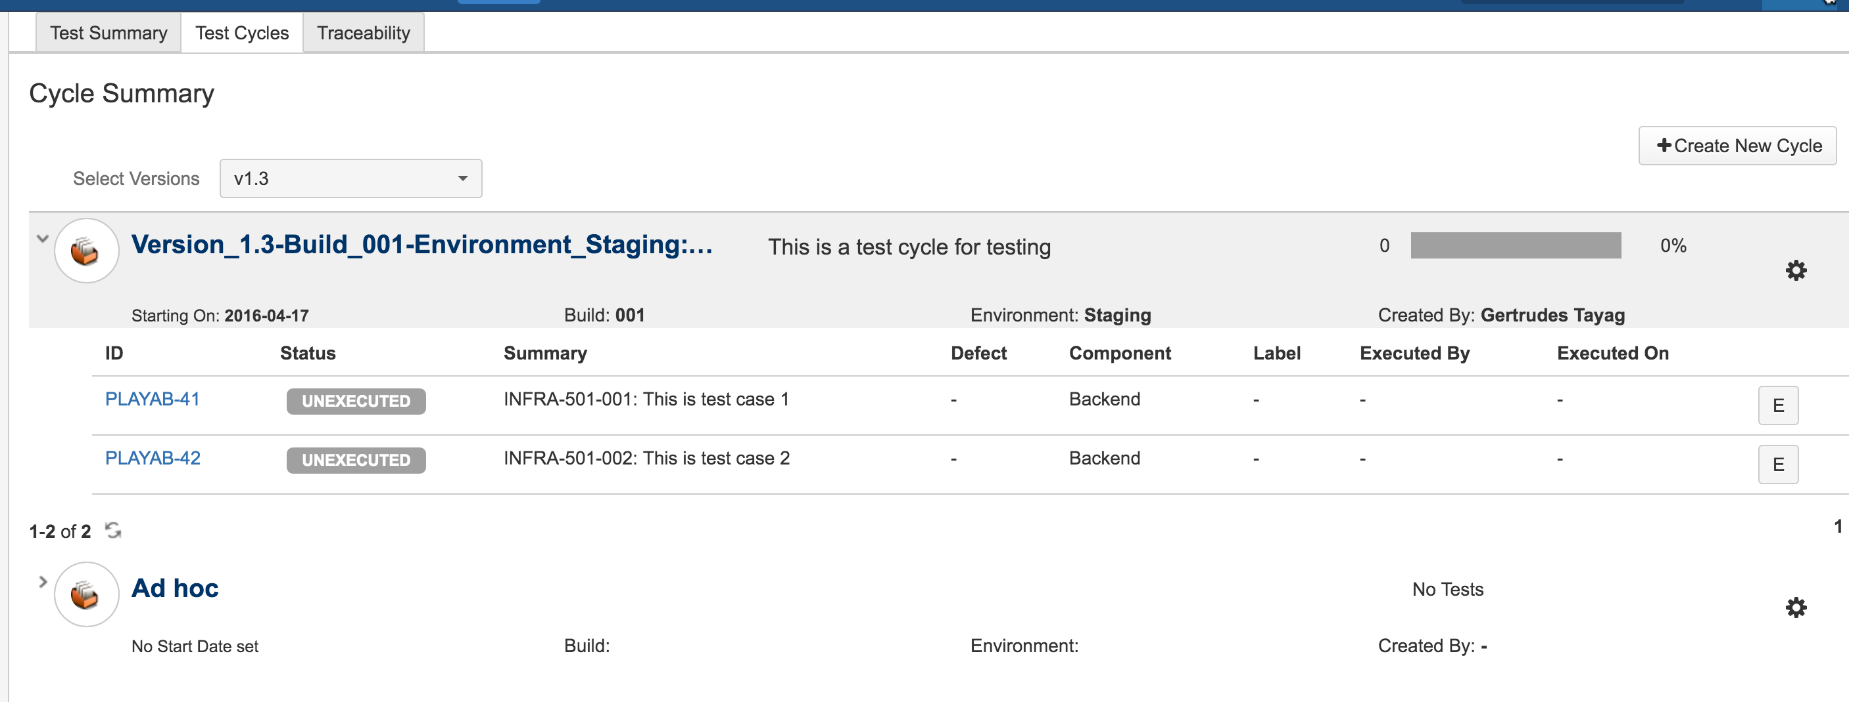

Executing Test Cases
- When it is time to execute the test cases, just open the test cycle
- On the Test Cycle Screen click the letter “E”
- The execution page of the test case shows:
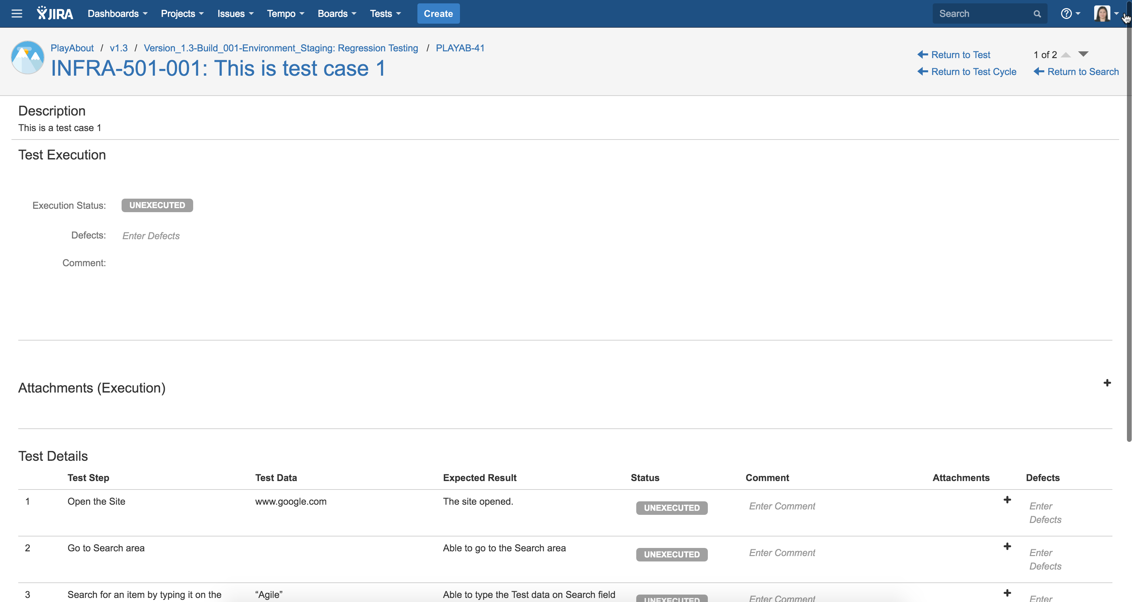
- Go to Test Details section
- Execute per steps
- Once a step is tested click on the Status
- Change the status to either Pass, Failed, WIP, Blocked and click the check icon
- You can put on the comment section the Actual Results
- You can add an attachment per step
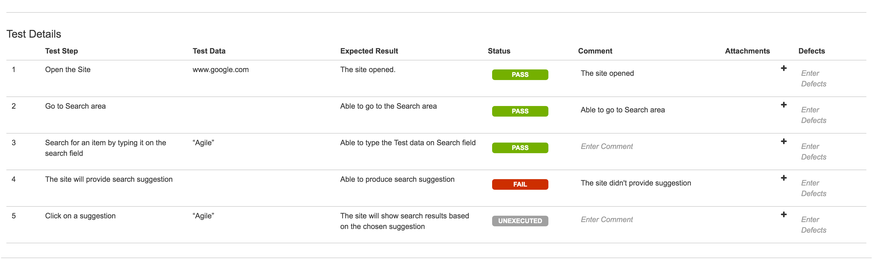
- You can enter a defect if the step has failed. Under step level, you can create the defect directly. Format will be: <Test Case ID>: Bug Description.
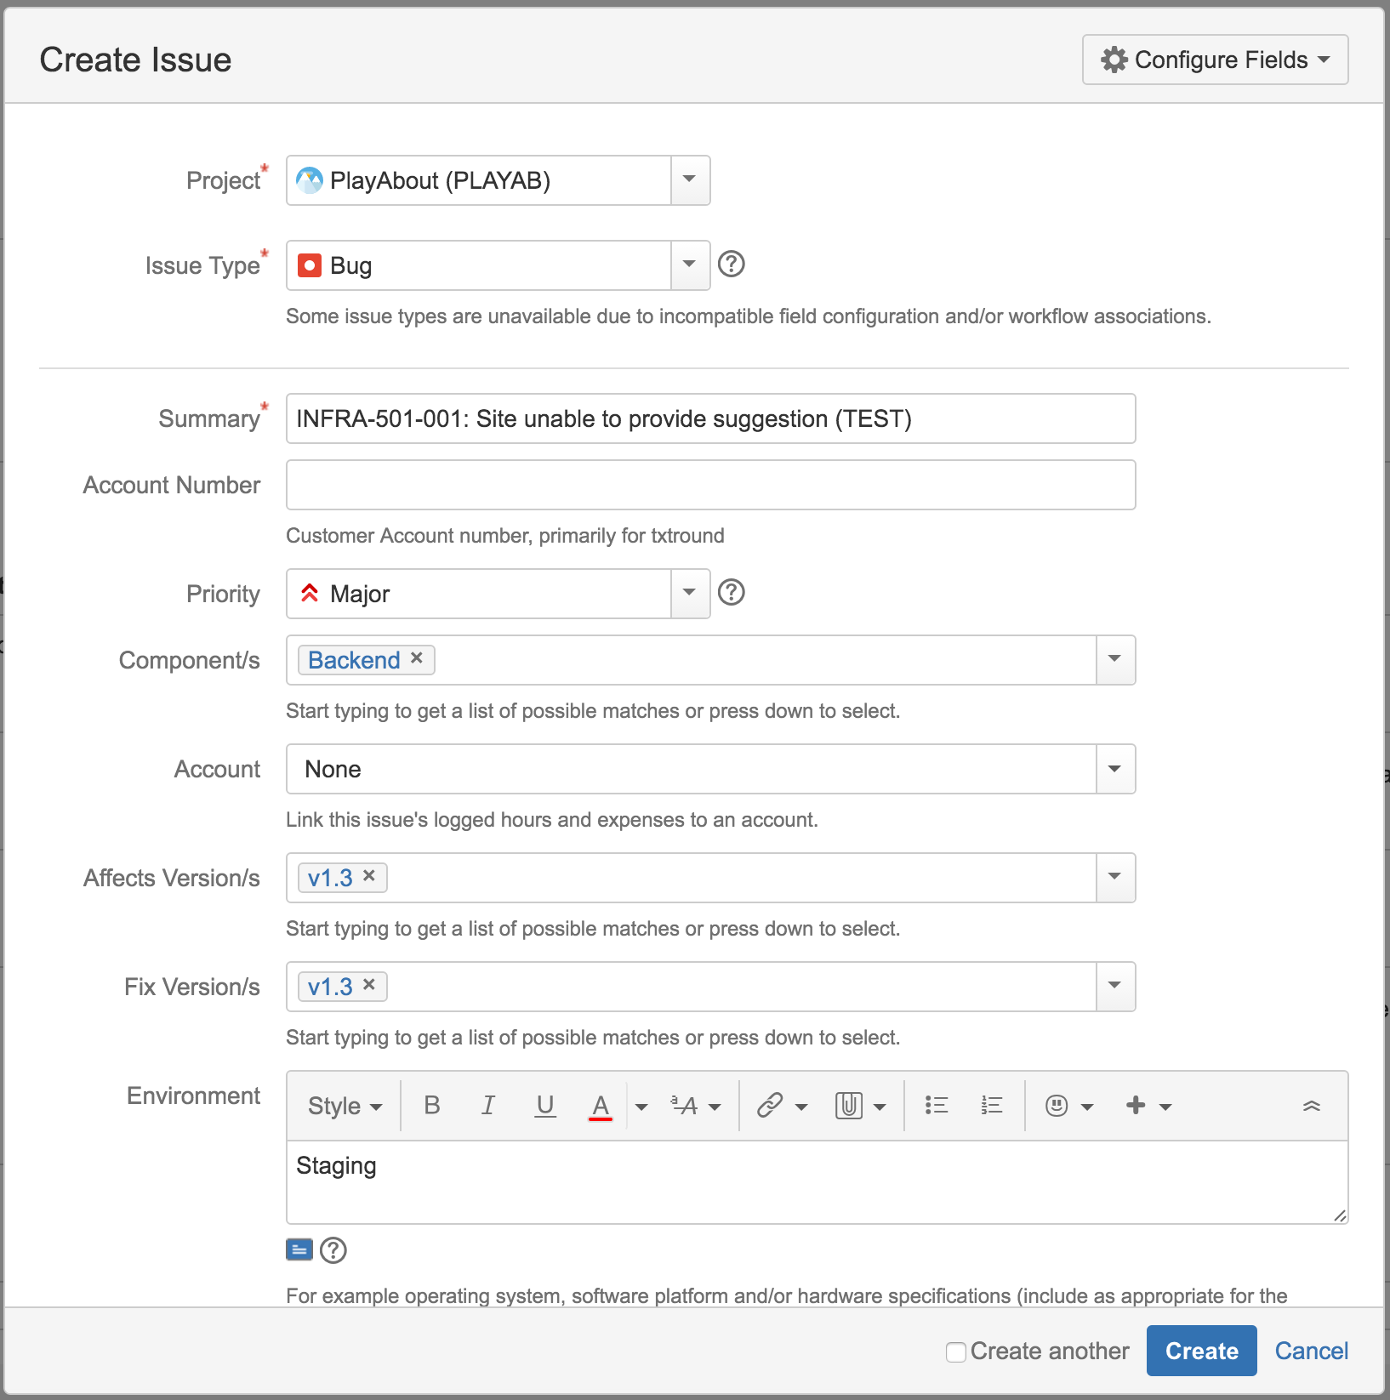
- Add defect
- Notice that the added defect is associated with the failed step.
- Finish executing the steps
- On the test case level, associate the created defect as it does not automatically associated with the test case.
- Change the Execution Status
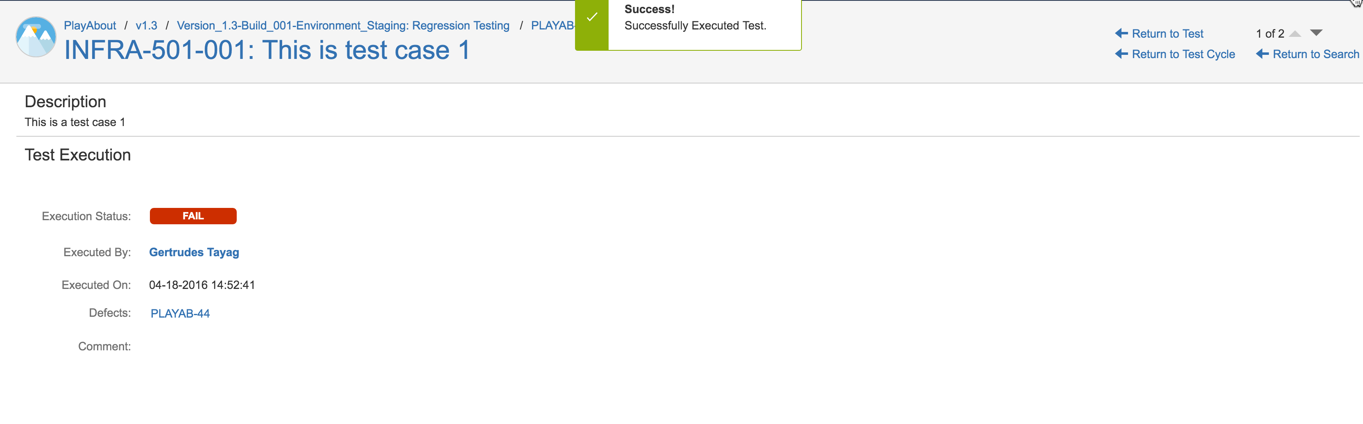
- Go back to the test cycle
- The test case is now executed and status plus defects are changed
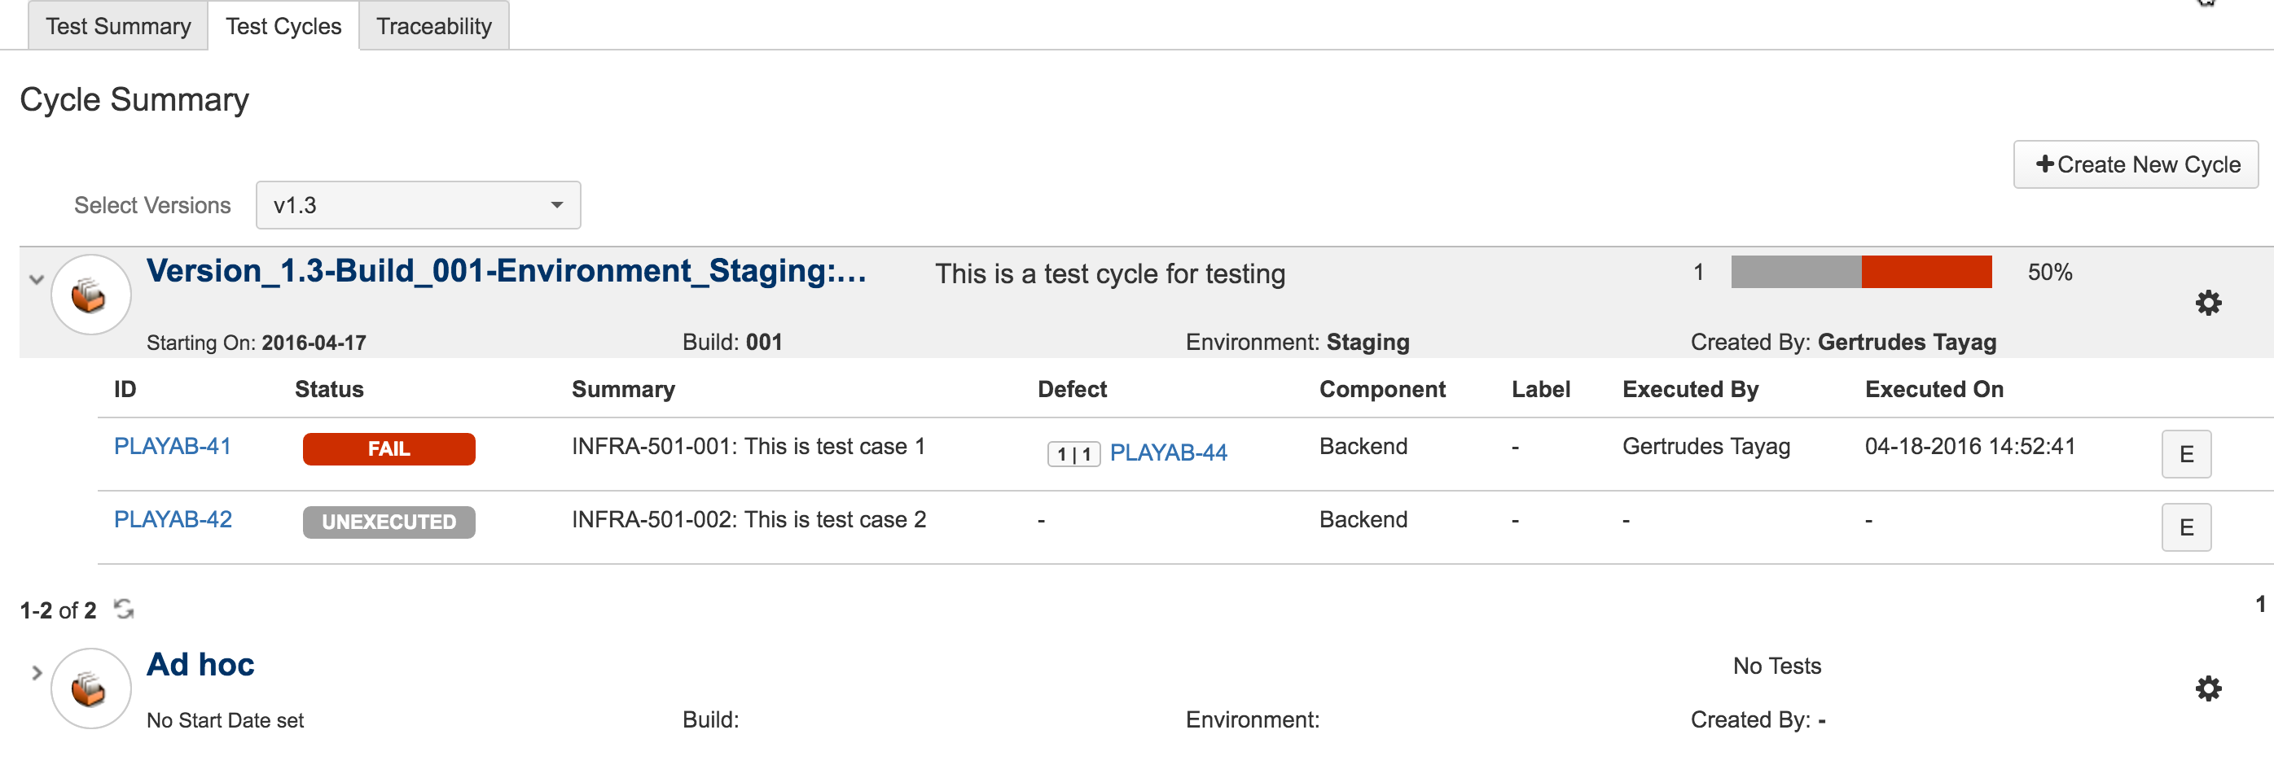
- Continue to execute the test cases under the test cycle.
- Once the test cases are executed, the test cycle will display the status of the tests
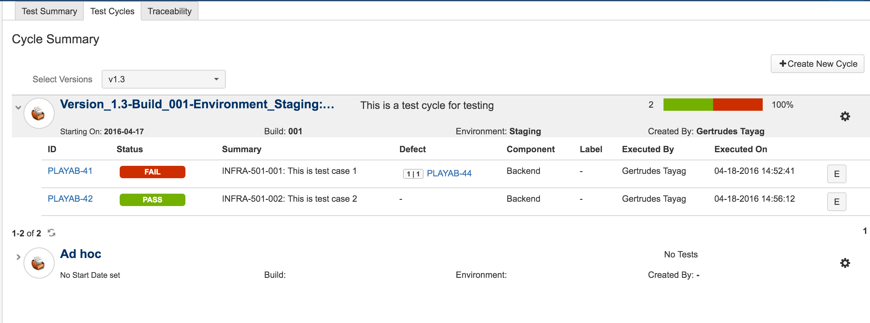

Re-using the test cycle for different tests
- Click on the wrench icon of the test cycle you want to re-run
- Click Clone Cycle
- The Create Cycle form shows with all of the details from original Test Cycle shows.
- Use the format on creating a test cycle on Adding Test Cases to Test Cycles
- All test cases under the test cycle will be duplicated and will have a unexecuted status
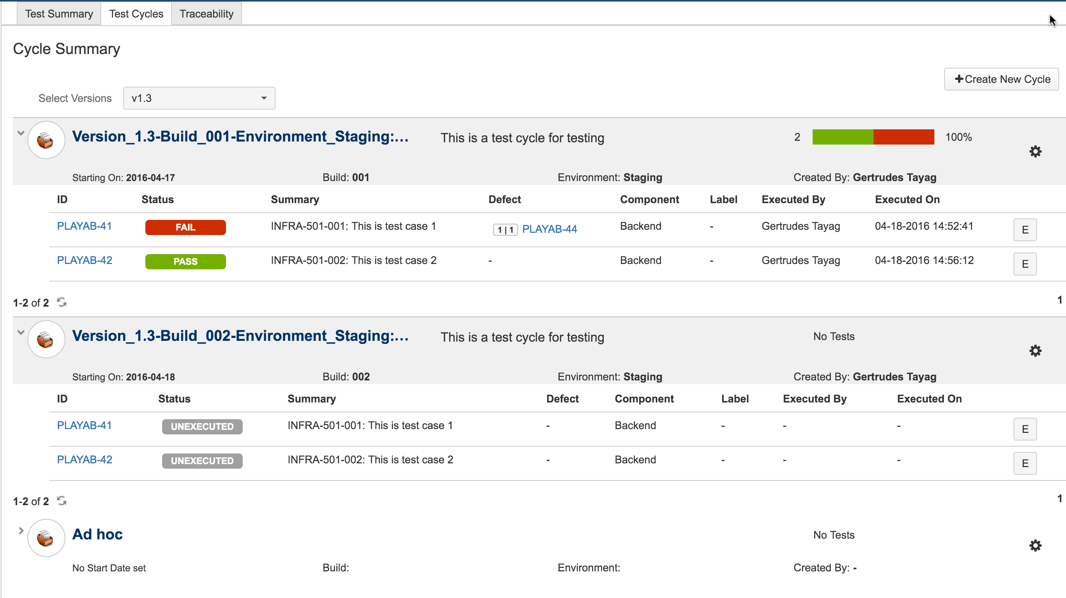
- Execute the test cases again when needed.

Others
- On the test cases, each test cycle and test execution are listed :
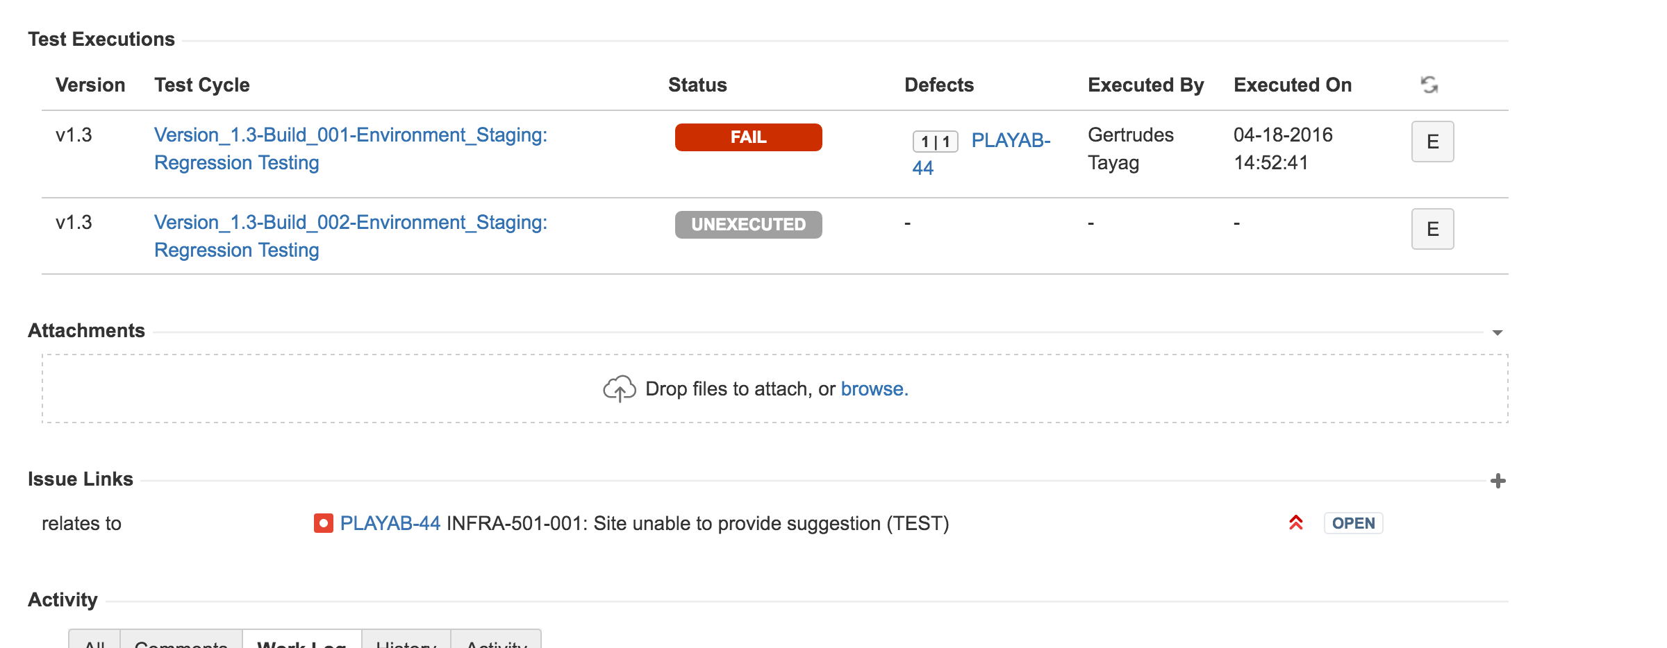
- Under each project, you can access all your tests and status:
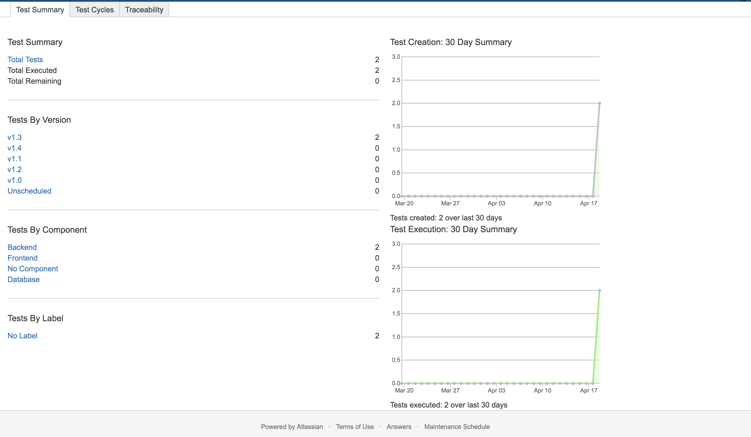
- Test Report can be viewed under Test Execution Report
